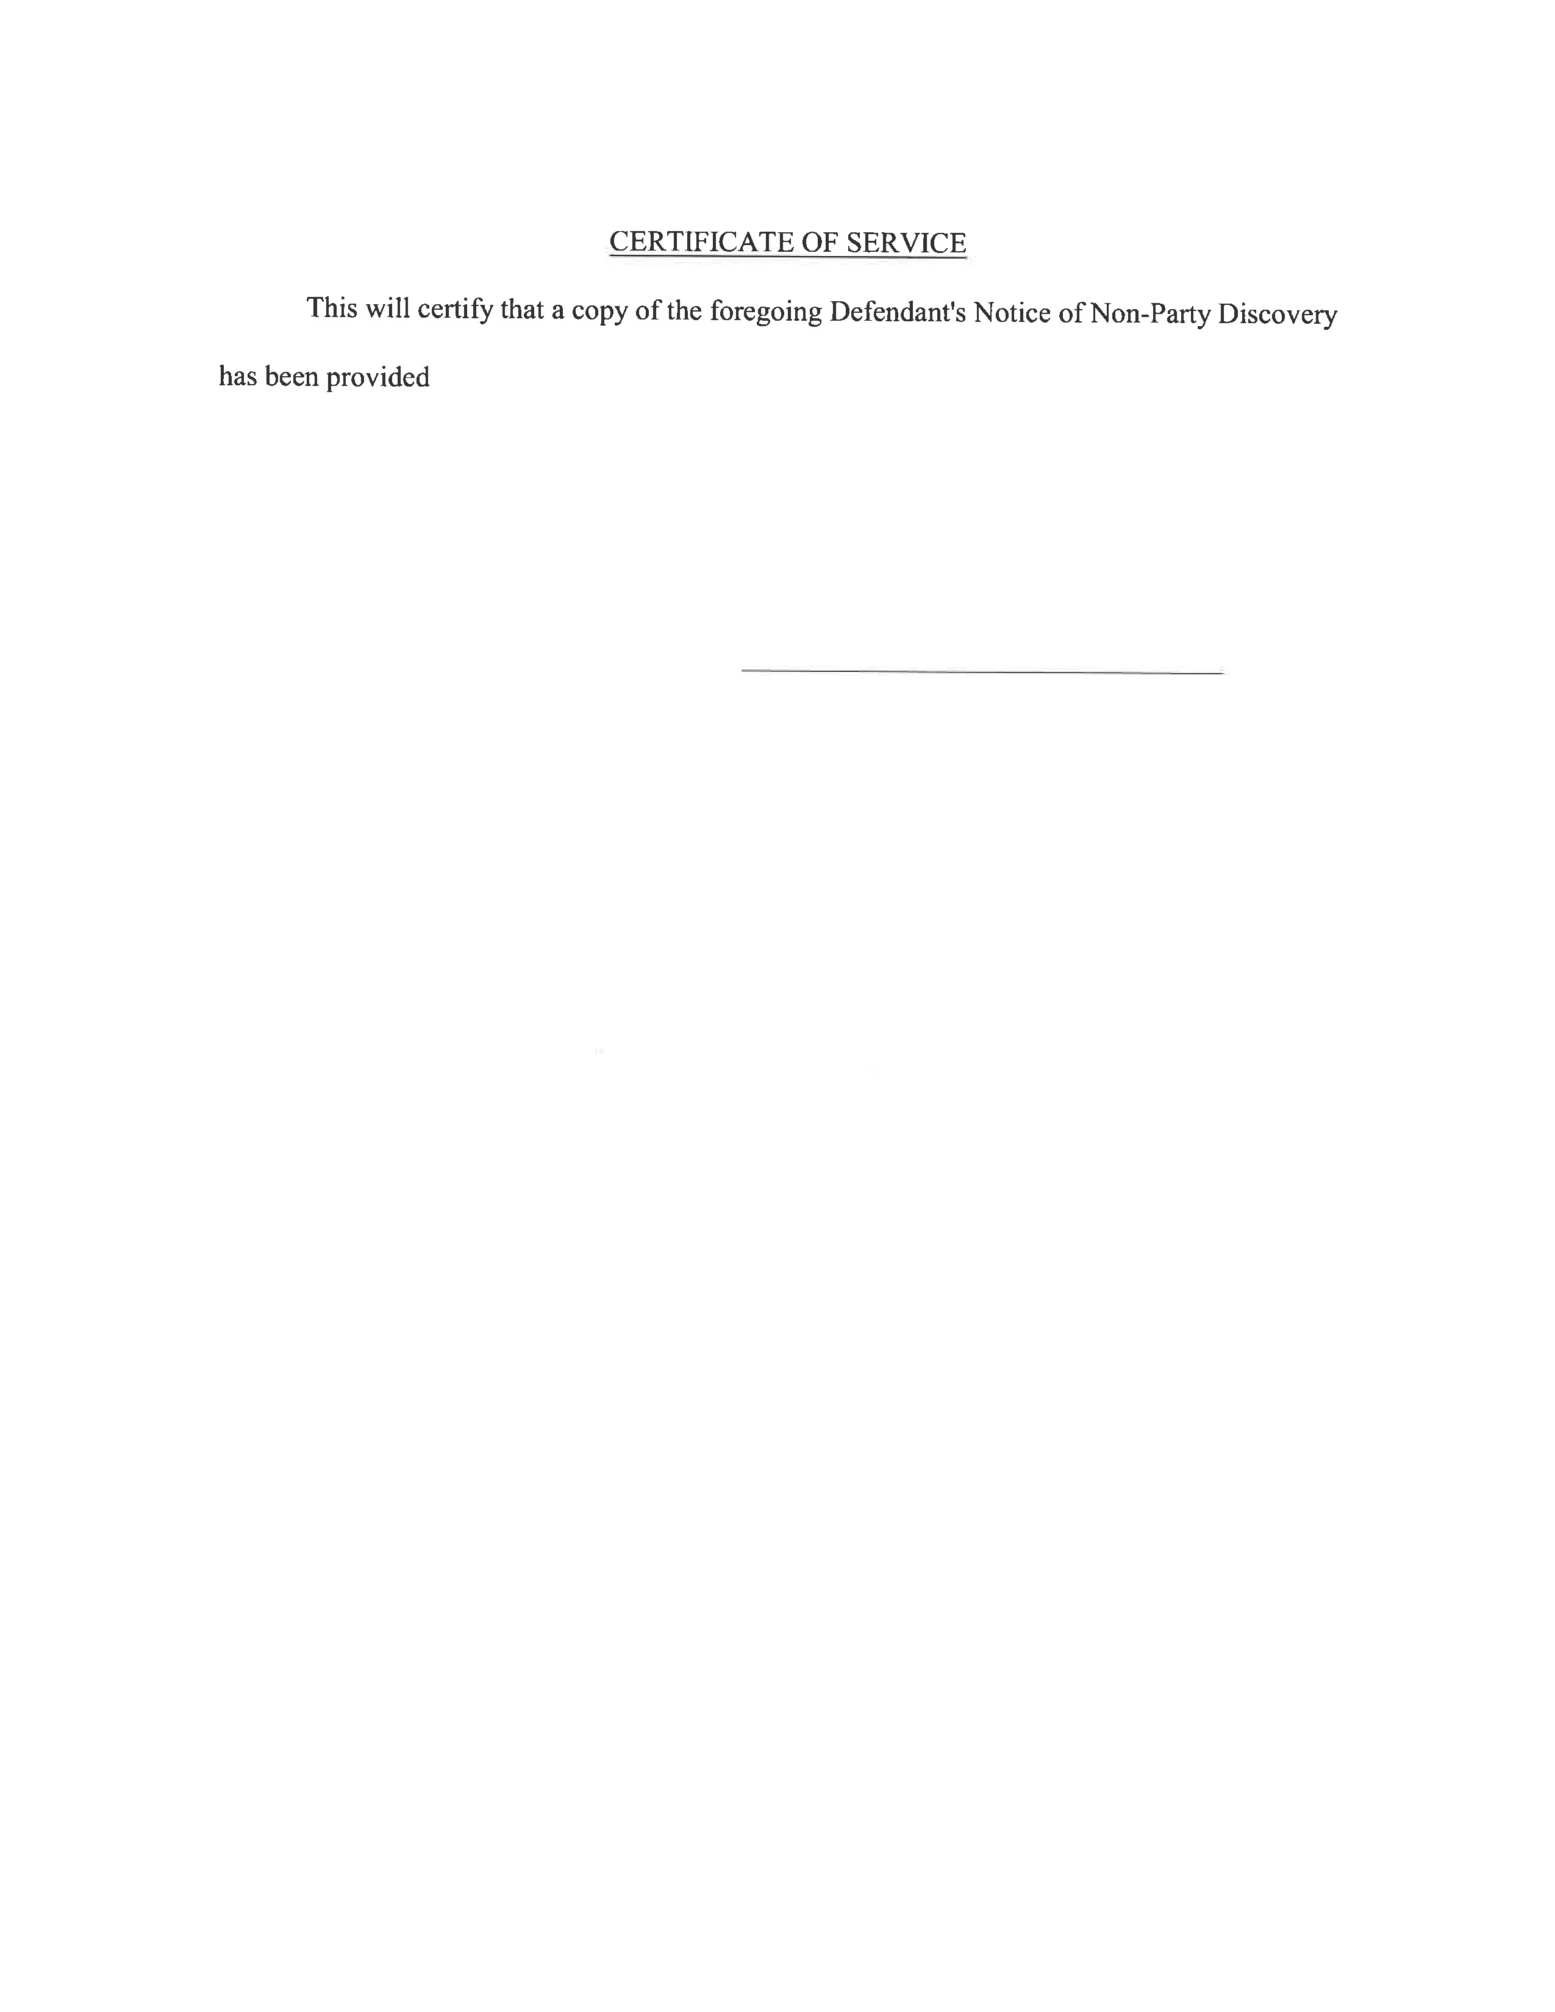
Maureen O’Connor 208781
This will certify that a copy of the foregoing Defendant’s Notice of Non-Party Discovery

has been provided Jeffrey Curry, Rosenbaum & Associates, PC, 1818 Market Street, Ste 3200,

Philadelphia, PA 19103-0000, via U.S. Mail, postage prepaid, on Sunday, November 8, 2026.
Lucas and Cavalier, LCC
1500 Walnut Street
Suite 1500
Philadelphia, PA 19102-0000
Telephone: (215) 751-9192

Order No: 01-35503

